ICONIC AEGEAN - 4 nights

ALL INCLUSIVE

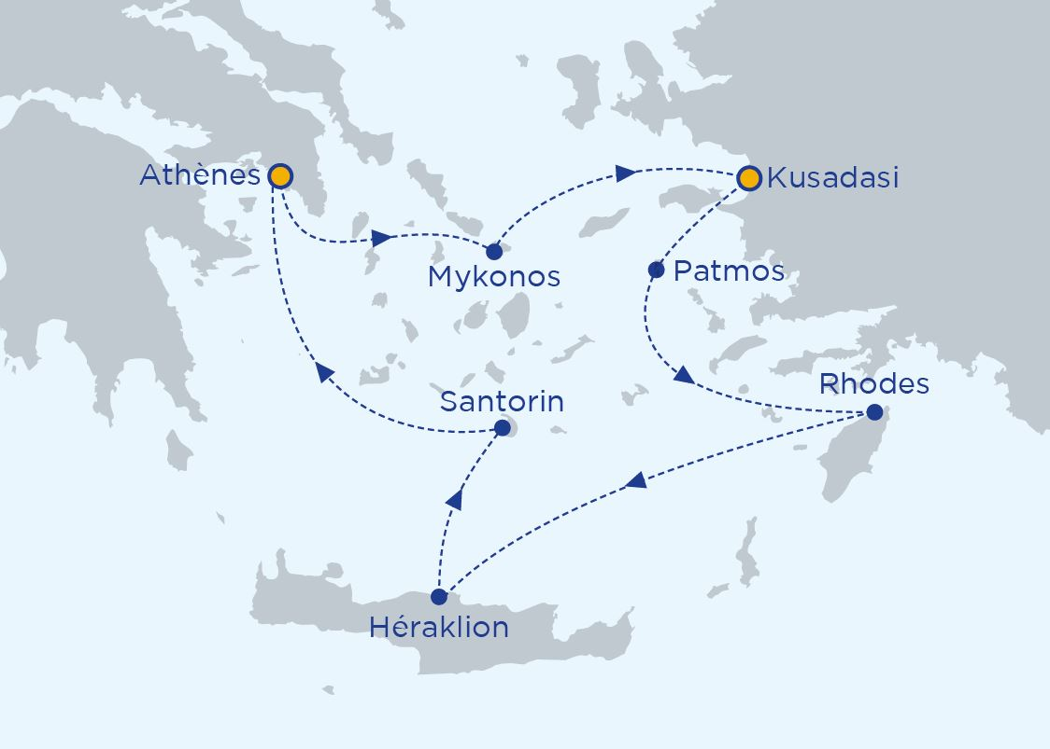
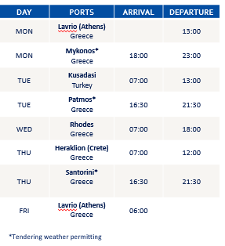
Your ship : CELESTYAL OLYMPIA

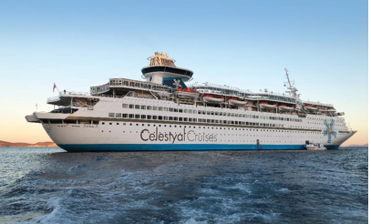
· 1,664 passengers with 724 cabins (included 9 cabins with balcony)
· All cabins have TV, air conditioning, phone, hair dryer,
^{- All suits have minibar}
^{- Wifi on board}
^{- Doctor on board}
^{- 2 Restaurants and 5 bars}
· 2 Swimming pool, fitness room, spa et beauty centre
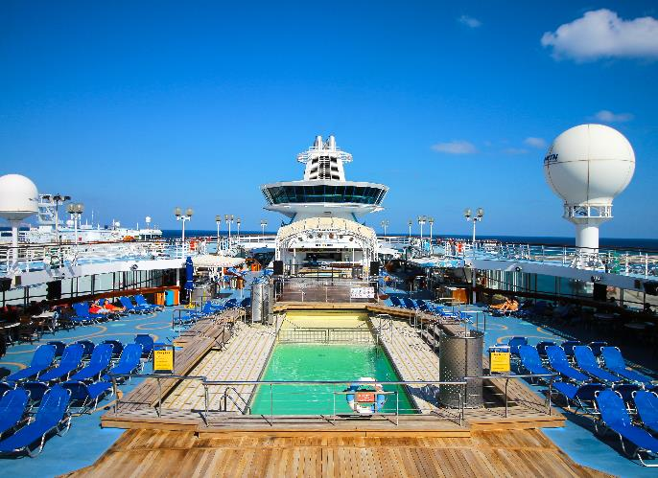
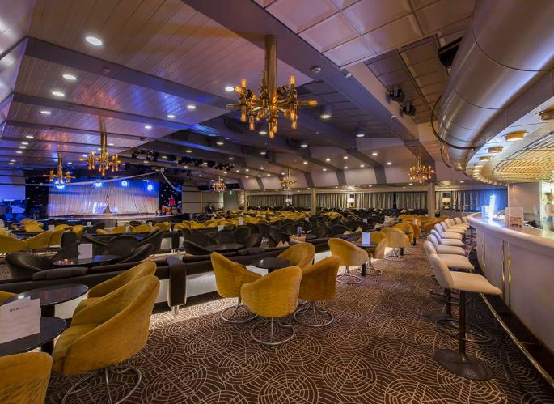

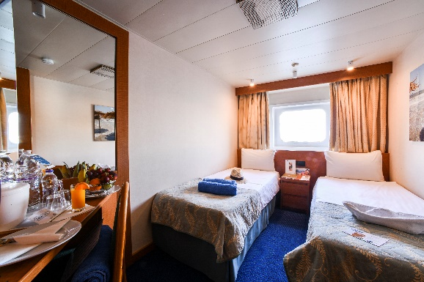
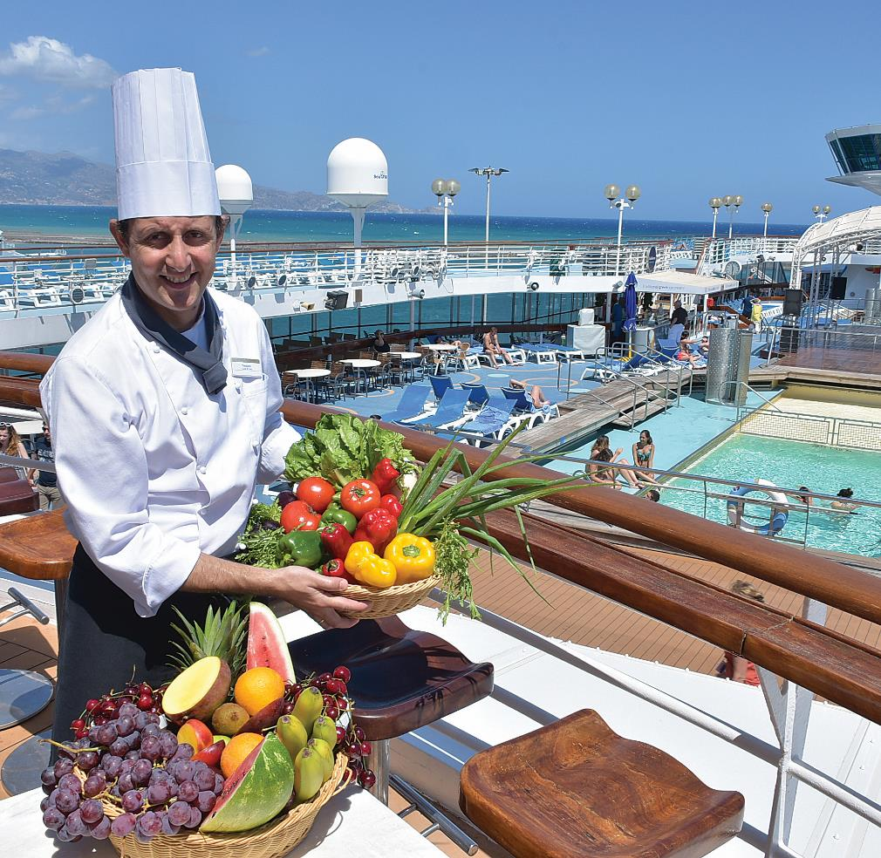
SERVICES TO OUR GUEST

- Assistance at the reception in different languages
- Staff available on different places on board
- Menus available in different languages
- ‘Daily’ available in different languages
- Included excursions in English, French, German (mini 30 pax for optional excursion)

ALL INCLUSIVE CRUISE

- Meals on board
- Unlimited classic drinks on board
- A selection of excursions included Animations à bord
- Entertainment on board
- Entertainment on board
- Entertainment on board

DAY 01 : Athens/Mykonos
We leave Athens and head for beautiful Mykonos in the Cyclades. The island, according to Greek mythology, was formed by the bodies of giants slain by Hercules. The most recognizable site on Mykonos is the row of immaculate picture postcard white windmills overlooking the water. Every visitor takes that picture. The Old Town has many delightful cafes and tavernas along its winding alleys and time will pass very quickly in these lovely, relaxing surroundings.

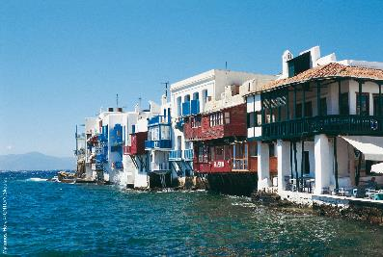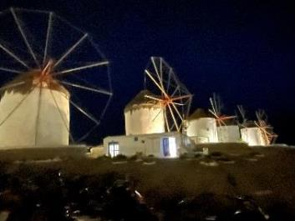

DAY 02 : Kusadasi/Patmos
Vibrant and colourful, Kusadasi in Turkey is the gateway to the Hellenistic ruins of Ephesus, famed for the Temple of Artemis, one of the Seven Wonders of the Ancient World. You can explore Ephesus on our complimentary tour.
Our next port of call is Patmos, a small and charming island a little over 20 square kilometres in size and lying in the Dodecanese. Biblical legend has it as the supposed location of the vision to John the Baptist in the Book of Revelations and where it was written.

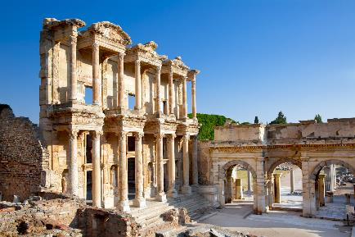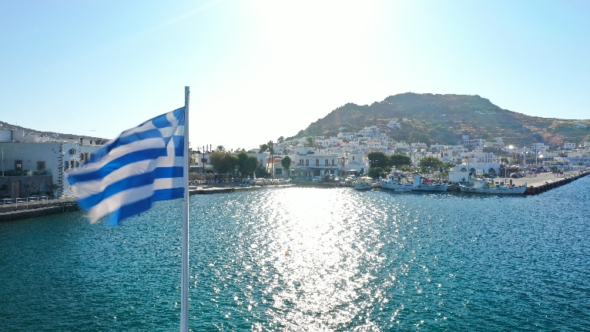

DAY 03 : RhodOs
His remains are nowhere to be seen of course but the Colossus of Rhodes once bestrode the harbour which gives us another link to the Seven Wonders. Lose yourself in the maze of atmospheric cobbled streets of the Old Town (a World Heritage Site) in that will transport you back to the Byzantine Empire and be sure to wander through the Knights Quarter and the Palace of the Grand Master. Indeed Rhodes is also known as the Island of the Knights. Our itinerary allows us a whole day here which gives plenty of opportunity to discover the clear waters, wonderful beaches and lush wooded valleys. Our complimentary excursion will take you to Lindos, the Acropolis, then on to the Old Town of Rhodes for a walking tour.

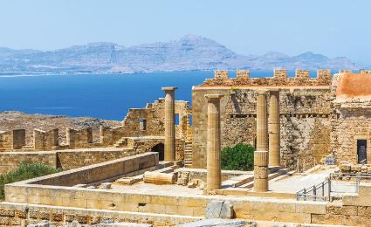
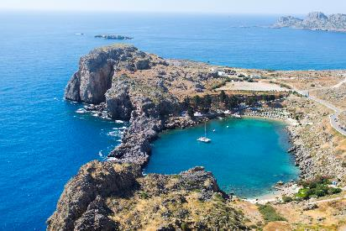

DAY 04 : Crète (Héraklion)/SantorinI
From one evocative island to another. Crete is Greece’s largest island and the fifth largest in the Mediterranean, a place of myths and legends. There will also be the opportunity to visit the capital Heraklion and absorb some of its extraordinary history. We then enjoy an evening in incomparable Santorini where you may get the chance to see the blue domed church at Oia. There will also be time for a wonderful, traditional meal at one of the many cliffside restaurants

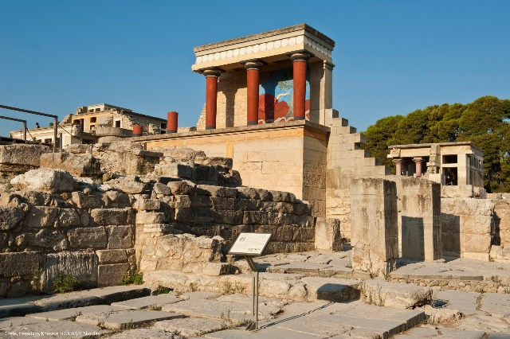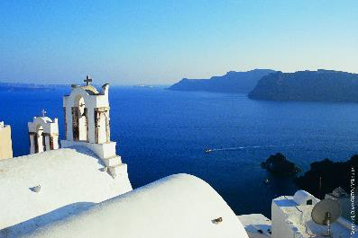

DAY 05 : Athèns –
We return to the capital in the morning after an exciting journey of discovery.

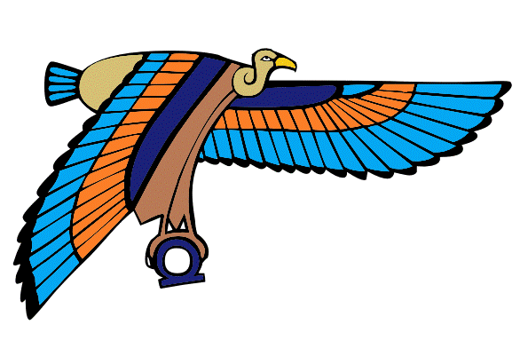
F.I.H.C.A. – Iconic Aegean Cruise Greece

From September 18th till September 23rd , 2022

Surname : _____________________________________________________
First Name : _____________________________________________________
Phone : _____________________________________________________
Email : _____________________________________________________

Cost per person in double interior cabin room : 975 €uros
Cost per person in single interior cabin : 1.300 €uros
Cost per person in double exterior cabin room : 1.100 €uros
Cost per person in single exterior cabin : 1.475 €uros

I confirm my participation in :
☐ Double interior room with Mrs / Mr ________________________________________
☐ Single Room interior cabin
☐ Double exterior cabin with Mrs / Mr _______________________________________
☐ Single Room exterior cabin

Payment schedule
50 % deposit to be paid upon registration
50 % final payment two months before departure = 15th July 2022

Cancellation policy
Cancellation before June 15th : you pay 25 %
Cancellation from June 15th till July 15th : you pay 50 %
Cancellation from July 16th till August 15th : you pay 75 %
Cancellation after August 15th : you pay 100 %
No insurance is included in this payment.

Credit card information
American Express / Visa / Master Card
Name on the card : ____________________________________________________
Credit card number : ___________________________________________________
Expire date : _____/_____
CVV 3 digits on the back of the card : __________
You may send these 3 digits by mail if you are concerned about security.

Signature for agreement

Please return this document by mail to : bernard@amarante.be
Avenue des statuaires 47
1180 Uccle
Tel : +32 2 345 88 88
bernard@amarante.be

